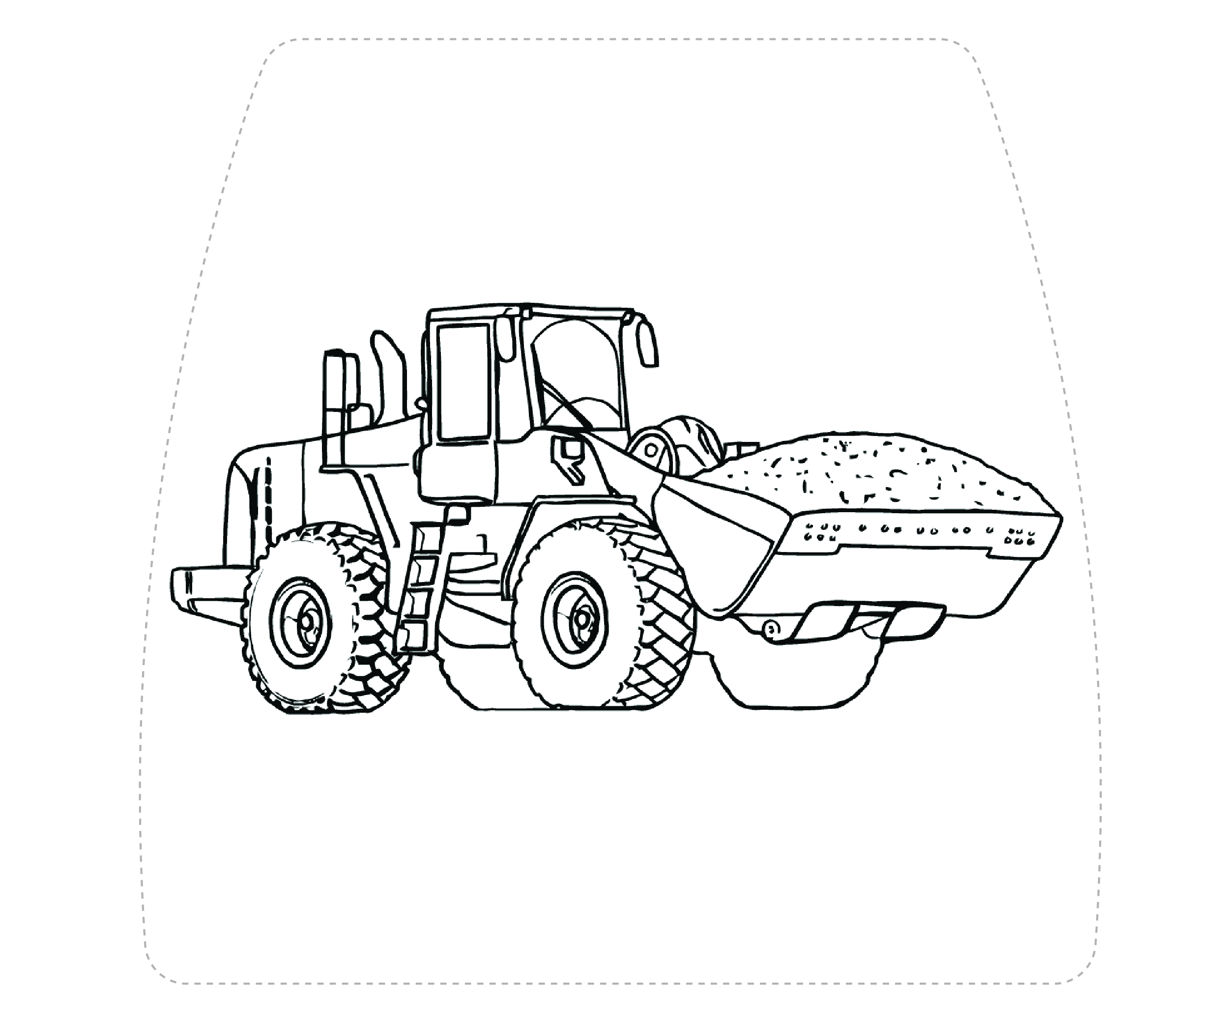

TYPE YOUR NAME HERE

Simply print off, cut out and hey presto, a new look for your lunchbox!



Please ensure children are supervised when cutting

**SIZE: A4**